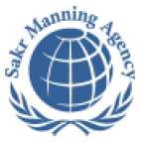 | SAKR MANNING AGENCY  FOR RECRUITING EGYPTIAN LABOR ABROAD | Issue Date | 15.05.2022
 | SAKR MANNING AGENCY  FOR RECRUITING EGYPTIAN LABOR ABROAD | Revision Date | 19.07.2022
 | Crewing Management Manual  Seafarer Employment Application | Revision | 1.1
 | Crewing Management Manual  Seafarer Employment Application | Page | 3
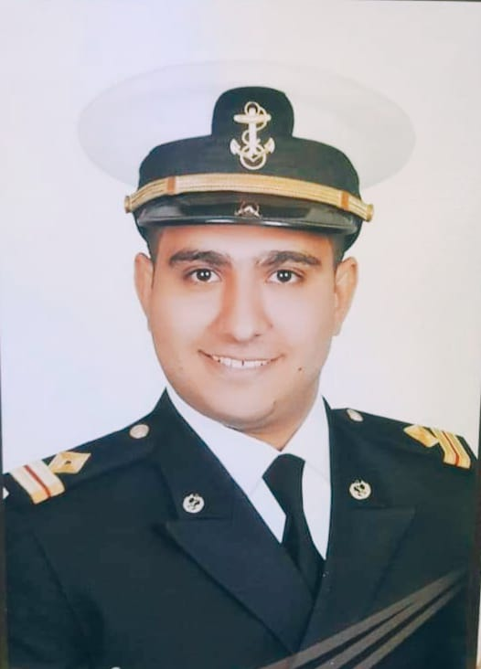
Application For Position as | 3rd Engineer
Register Code. | EO-3.063
Other Position (If Any) | 4th Engineer
Register Date | 21/03/2023
Last up Date Data | 18/03/2023
Expected Salary

1. PERSONAL DETAILS
Full Name |  | Tarek Mohamed Ahmed
Date Of Birth |  | 01/09/1994 |  |  |  |  |  |  | Place Of Birth |  |  |  |  |  |  |  | Sohag
Nationality |  | Egyptian |  |  |  |  |  |  | Marital Status |  |  |  |  |  |  |  | Single yes |  |  |  |  |  |  |  | Married
Height (Cm) |  | 178 |  |  |  |  |  |  | Overall Size |  |  |  |  |  |  |  | XL |  |  |  |  | Shirt Size |  |  |  |  |  | XL
Weight (Kg) |  | 80 |  |  |  |  |  |  | Trouser Size |  |  |  |  |  |  |  | 36 |  |  |  |  | Shoes Size |  |  |  |  |  | 43
2. EDUCATION
College / School |  | Bachelor degree in marine engineering from Arab academy
Marline Test |  | Issued Date |  |  |  |  | Result % |  |  |  | Issued By (Authority) |  |  |  |  |  |  |  |  |  | Issued At
English Language |  | Fluent |  |  |  |  |  | Good yes |  |  |  |  | Average |  |  |  |  |  |  |  | Poor
……… Language  ( ) |  | Fluent |  |  |  |  |  | Good |  |  |  |  | Average |  |  |  |  |  |  |  | Poor
3. CONTACT DETAILS
Home Address / City |  |  | Alex-smouha -Green plaza
E-Mail |  |  | Tarekbadawy15@yahoo.com |  |  |  |  |  |  | Mobile / Tel |  |  |  |  |  | 01018378151 |  |  |  |  |  |  | 01555541994

4. TRAVEL DOCUMENTS
Type |  | Document No. |  |  |  | ISS. Date |  |  | Exp. Date |  |  |  |  | ISS. By (Authority) |  |  |  |  |  |  |  |  |  | Place of Issue
Passport |  | A31344541 |  |  |  | 31/08/2022 |  |  | 30/08/2029 |  |  |  |  | Egyptian Authority |  |  |  |  |  |  |  |  |  | Alex
Seaman Book |  | S00004924 |  |  |  | 10/12/2019 |  |  | 18/09//2024 |  |  |  |  | EAMS |  |  |  |  |  |  |  |  |  | Alex.
Other Seaman Book

5. PROFESSIONAL QUALIFICATION / CERTIFICATE OF COMPETENCY
Certificate Name |  |  |  |  | Number | Issue Date |  |  |  |  |  | Expiry Date |  |  |  |  |  | Issued By |  |  |  |  |  |  |  |  | Issued At
COC |  |  |  |  | 6031 | 20/11/2019 |  |  |  |  |  | 18/09/2024 |  |  |  |  |  | EAMS |  |  |  |  |  |  |  |  | Alex.
GOC |  |  |  |  |  |  |  |  |  |  |  |  |  |  |  |  |  | NTRA |  |  |  |  |  |  |  |  | Cairo
D.P. INDUCTION
D.P. ADVANCED
D.P. OPERATOR (UNLIMITED)
6. NEXT OF KIN
Full Name | Eslam Mohamed Ahmed |  |  |  |  |  |  |  |  |  |  |  |  |  | Relationship |  |  |  |  | Single
Address | Sohag-dar elsalam
Tel. No. | 01100589071 |  |  |  |  |  |  |  |  | Mobile |  |  | 01555541994
7. HEALTH CERTIFICATES & VACCINATIONS
Flag State |  |  |  | Number |  |  | Issue Date |  |  |  |  | Expiry Date |  |  |  |  |  |  | Issued By |  |  |  |  |  |  | Issued At
International Medical |  |  |  | 03055 |  |  | 17/08/2021 |  |  |  |  | 16/08/2023 |  |  |  |  |  |  | EAMS |  |  |  |  |  |  | Alex.
Yellow Fever |  |  |  |  |  |  | 22/12/2019 |  |  |  |  |  |  |  |  |  |  |  | Ministry of Health |  |  |  |  |  |  | Alex
Cholera |  |  |  |  |  |  |  |  |  |  |  |  |  |  |  |  |  |  | Ministry of Health
Covid-19 |  |  |  | Vaccination Name |  |  | First Dose |  |  |  |  | Second Dose |  |  |  |  |  |  | (Other Does or Remarks)
 |  |  |  | Johnson |  |  | 27/09/2022

8. MARINE COURSES
Course Name | Number | Issue Date | Expiry Date | Issued By / At
Personal Survival Techniques
Proficiency In Personal Survival Techniques | 40721/19/EG | 17/11/2019 | 4/11/2024 | EAMS
Fire Prevention and Fire Fighting
Advanced Fire Prevention and Fire Fighting | 40724/19/EG | 17/11/2019 | 30/10/2024 | EAMS
Elementary First Aid | 40725/19/EG | 17/11/2019 | 18/09/2024 | EAMS
Medical Care Studies
Personal Safety and Social Responsibilities | 40723/19/EG | 17/11/2019 | 28/10/2024 | EAMS
Proficiency Of Security Awareness Training Seafarers | 40729/19/EG | 17/11/2019 | 11/11/2024 | EAMS
Proficiency as a ship Security officer ( PSSO )
Proficiency In Survival Craft & Rescue Boats | 40722/19/EG | 17/11/2019 | 6/11/2024 | EAMS
G.M.D.S.S
Communications
Advanced Communications
ECDIS Advanced Simulator (Management Level)
ECDIS Simulator (Operation Level)
Prevention and Combating of Marine Pollution | 40728/19/EG | 17/11/2019 |  | EAMS
Radar & ARPA Simulator and Search &rescue
ARPA Simulator and Search
Marine Radar and automatic Radar Plotting
Bridge resource Management (B.R.M)
Engine resource Management (E.R.M)
Navigational Watch keeping
Proficiency for Rating forming part of Navigational watch (II/4) |  |  |  | EAMS / Alex.
High voltage training – operation of ship (1000 Volt and More)
Passenger Safety Cargo Safety and Hull integrity
Crowd Management Training
Crisis Management and Human Behavior Training
Safety training for Personal Prov. Direct Passengers
Practical Ability to Prepare Meals and (MLC 2006)
Personal Hygiene and Envir. Protection (MLC 2006)
Safety and Health in the Provision Meals (MLC 2006)
Food Storage and inventory Control (MLC 2006)
Ships Cook Certificate (MLC 2006) |  |  |  | EAMS / Alex.
Abel Seafarer Deck
Proficiency for Abel Seafarer Deck ( II/5 ) |  |  |  | EAMS / Alex.
Engineering Watch keeping |  |  |  | EAMS / Alex.
Proficiency for Rating forming part of a watch in engine room
Abel Seafarer Engine
Proficiency for Abel Seafarer Engine ( III/5 ) |  |  |  | EAMS / Alex.
Electro Technical Rating
Proficiency for Electro Technical rating ( III/7 ) |  |  |  | EAMS / Alex.

COMPLETE SEA – SERVICE DETAILS

Name: |  |  |  |  |  |  |  | Rank: |  |  |  |  |  |  |  | Register Code:
Company Name |  |  | Rank |  | Vessel Name |  |  |  | Signed On |  |  | Signed Off |  |  |  | Period |  |  | Vessel Type |  | D.W.T. |  |  |  |  | Engine Type |  |  | BH | KW
LDPL Middile East |  |  | 3rd Eng |  | ALM TINKA |  |  |  | 21/11/2022 |  |  | 08/03/2023 |  |  |  | 3 m 20d |  |  | Transshipment |  | 9163 |  |  |  |  | Cat |  |  | 6730 | 4*1257
Salem Almakrani co |  |  | 3rd Eng |  | Al Salmy 5 |  |  |  | 20/08/2021 |  |  | 28/07/2022 |  |  |  | 11m 10d |  |  | RORO ship |  | 12530 |  |  |  |  | MAK 12m |  |  | 4890 | 3600
JAOHAR Untted |  |  | 3rd Eng |  | JAOHAR ADAM |  |  |  | 15/08/2020 |  |  | 11/05/2021 |  |  |  | 9 m |  |  | Bulk, container |  | 5941 |  |  |  |  | Wartsila |  |  | 8000 | 5940
FERU SHIPPING CO |  |  | Cadet Eng |  | STARSHINA DEROV |  |  |  | 05/03/2015 |  |  | 05/09/2015 |  |  |  | 6 m |  |  | General cargo |  | 2576 |  |  |  |  | Resita |  |  | 1880 | 1400
SPECIALISED EXPERIENCE
Name |  |  |  |  |  |  |  |  |  | Type |  |  |  | From |  |  | To |  |  |  |  | Comments
I declare that the information I have given is, to the best of my knowledge, true and complete. I also declare that the documents submitted are genuine, given and sign by persons whose names appear on them.
 |  |  |  |  |  |  |  |  |  |  |  |  |  |  | DATE |  |  |  |  |  |  |  |  |  | SIGNATURE

